**ATM Transaction Dashboard Report**

**Introduction:**

This project, titled ATM Transaction Dashboard, was built using real-world data from Bank of Baroda. I developed this dashboard to analyze ATM transaction patterns, costs, and performance metrics across various regions. The primary aim was to showcase my skills in data analysis, visualization, and business insights during interviews, highlighting my ability to create impactful dashboards.

Using Power BI, I crafted interactive visualizations that provide insights into key performance indicators (KPIs) such as revenue, transaction volumes, uptime, and gross profit margins. This dashboard is designed to help stakeholders make informed, data-driven decisions to optimize ATM operations, reduce costs, and improve profitability.

In addition to data visualization, I designed all the background images for this project using Figma, ensuring a professional and cohesive visual theme throughout the dashboard.

**Objective**: The primary goals of this dashboard are

1. To provide a detailed analysis of ATM revenue and transaction patterns.
2. To assess the performance of different regions in terms of revenue generation and transaction volumes.
3. To track maintenance costs and evaluate their impact on overall ATM performance.
4. To utilize uptime and transaction data to enhance gross profit.

**Home Screen:**

This screen introduces the dashboard and provides navigation options for users to explore various sections. I designed the visual representation of ATM usage to immediately connect users with the concept of the dashboard. The home screen offers a user-friendly experience by clearly presenting the different sections of the dashboard: Home, Overview, and Details.I designed this screen using Figma, focusing on simplicity and intuitive navigation to ensure that users can easily access the relevant data and insights.

**Overview Section:**

This section provides a high-level summary of the entire ATM network's performance. Key metrics like Average Monthly Transactions, Average Monthly Revenue, Average Uptime, Average Total Cost, and Gross Profit % are prominently displayed at the top, offering a quick snapshot of overall ATM health.

* **Cost Analysis:** This provides a breakdown of ATM maintenance costs, categorized into Spare Repairs, CRA (Cash Replenishment Agent), and AMC (Annual Maintenance Contract) over different months. Understanding the cost structure allows decision-makers to identify and control operational expenses effectively.
* **Revenue and Transactions by Region:** This visualization showcases revenue generated across different states, such as Assam and Punjab, which have significant revenue figures. This helps focus strategic efforts on high-performing regions.
* **Transaction Trends:** This section highlights financial and non-financial transactions over different months, identifying seasonal patterns and helping forecast future demand.

**Why I Developed This Visualization:**

* **Key Metrics:** To provide a comprehensive view of the ATM network's overall performance, enabling stakeholders to quickly assess the health of operations.
* **Cost Analysis:** To break down maintenance costs and monitor their impact on profitability.
* **Regional Revenue Analysis:** To identify high-revenue regions, allowing the business to prioritize investments in those areas.
* **Transaction Trends:** To track financial and non-financial transactions over time, helping predict demand and optimize ATM services accordingly.

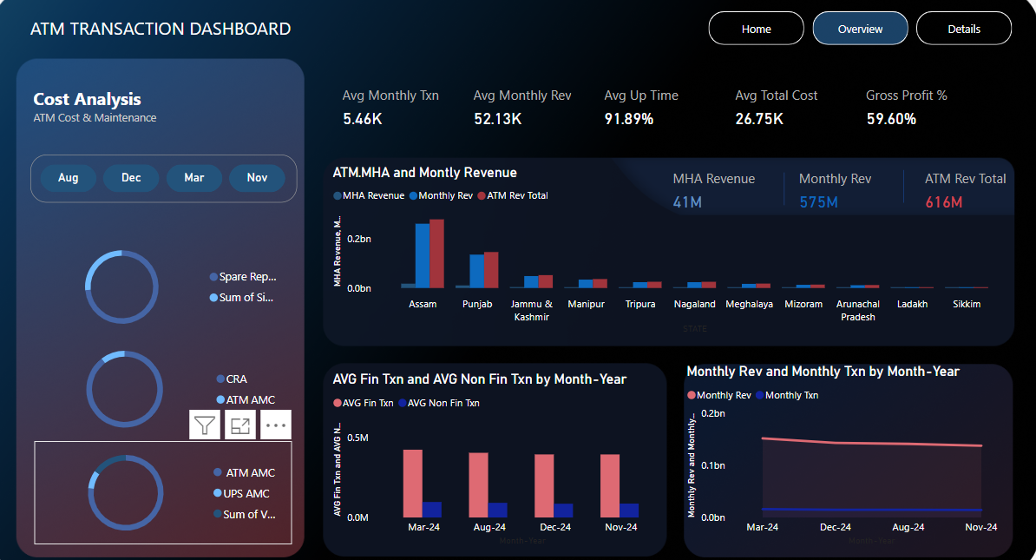

**Details Section:**

This section dives deeper into ATM performance, offering insights into revenue and transaction patterns at a granular level.

* **Range Analysis:** A comparative analysis of margin ranges for current and previous months. This visual categorizes ATMs by transaction count, helping to understand performance distribution across the network.
* **Revenue Performance:** This table provides detailed metrics on individual ATMs, including Monthly Revenue, Monthly Transactions, Gross Profit %, and Uptime. It helps identify which ATMs are underperforming and may require attention.
* **Comparative Analysis:** By comparing current and previous months' transaction ranges, this visual helps track performance trends and determine the effectiveness of implemented strategies.

**Why I Developed This Visualization:**

* **Range Analysis:** To segment ATMs based on transaction volume and profit margins, enabling stakeholders to prioritize upgrades or maintenance efforts.
* **Revenue Performance:** To provide detailed insights into individual ATM performance and allow for targeted interventions to optimize profitability.
* **Comparative Analysis:** To assess the impact of strategies over time and identify areas for improvement or change.

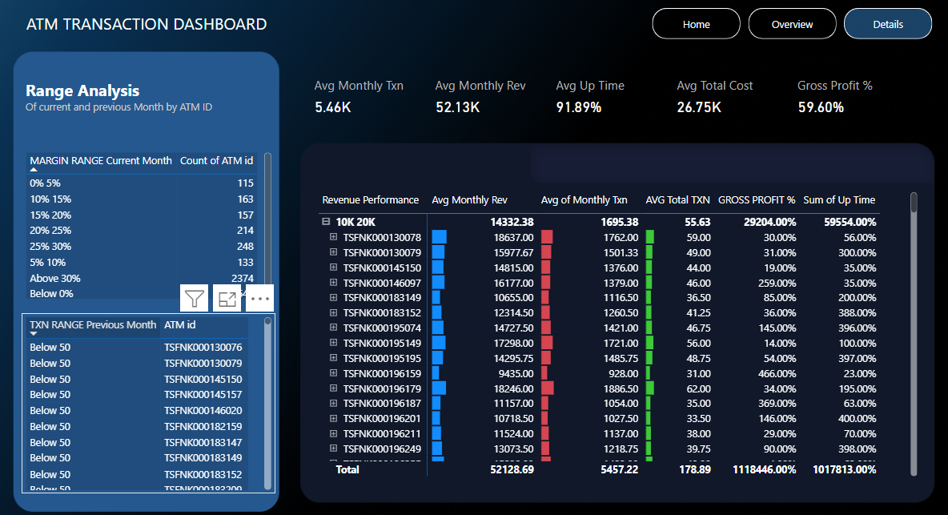

**Conclusion:** The ATM Transaction Dashboard provides a comprehensive view of ATM performance, cost management, and revenue analysis using Bank of Baroda's real-world data. By combining financial, operational, and transactional data, this dashboard enhances profitability and operational efficiency within ATM networks. This project is a strong demonstration of my skills in data analysis, Power BI visualization, and generating actionable business insights. By designing all the background images on Figma and integrating them into a cohesive visual theme, I’ve showcased my ability to not only analyze data but also design intuitive and professional dashboards. This project was developed to showcase my potential in interviews, demonstrating how I can contribute effectively to business intelligence and data-driven decision-making rolesTop of FormBottom of Form